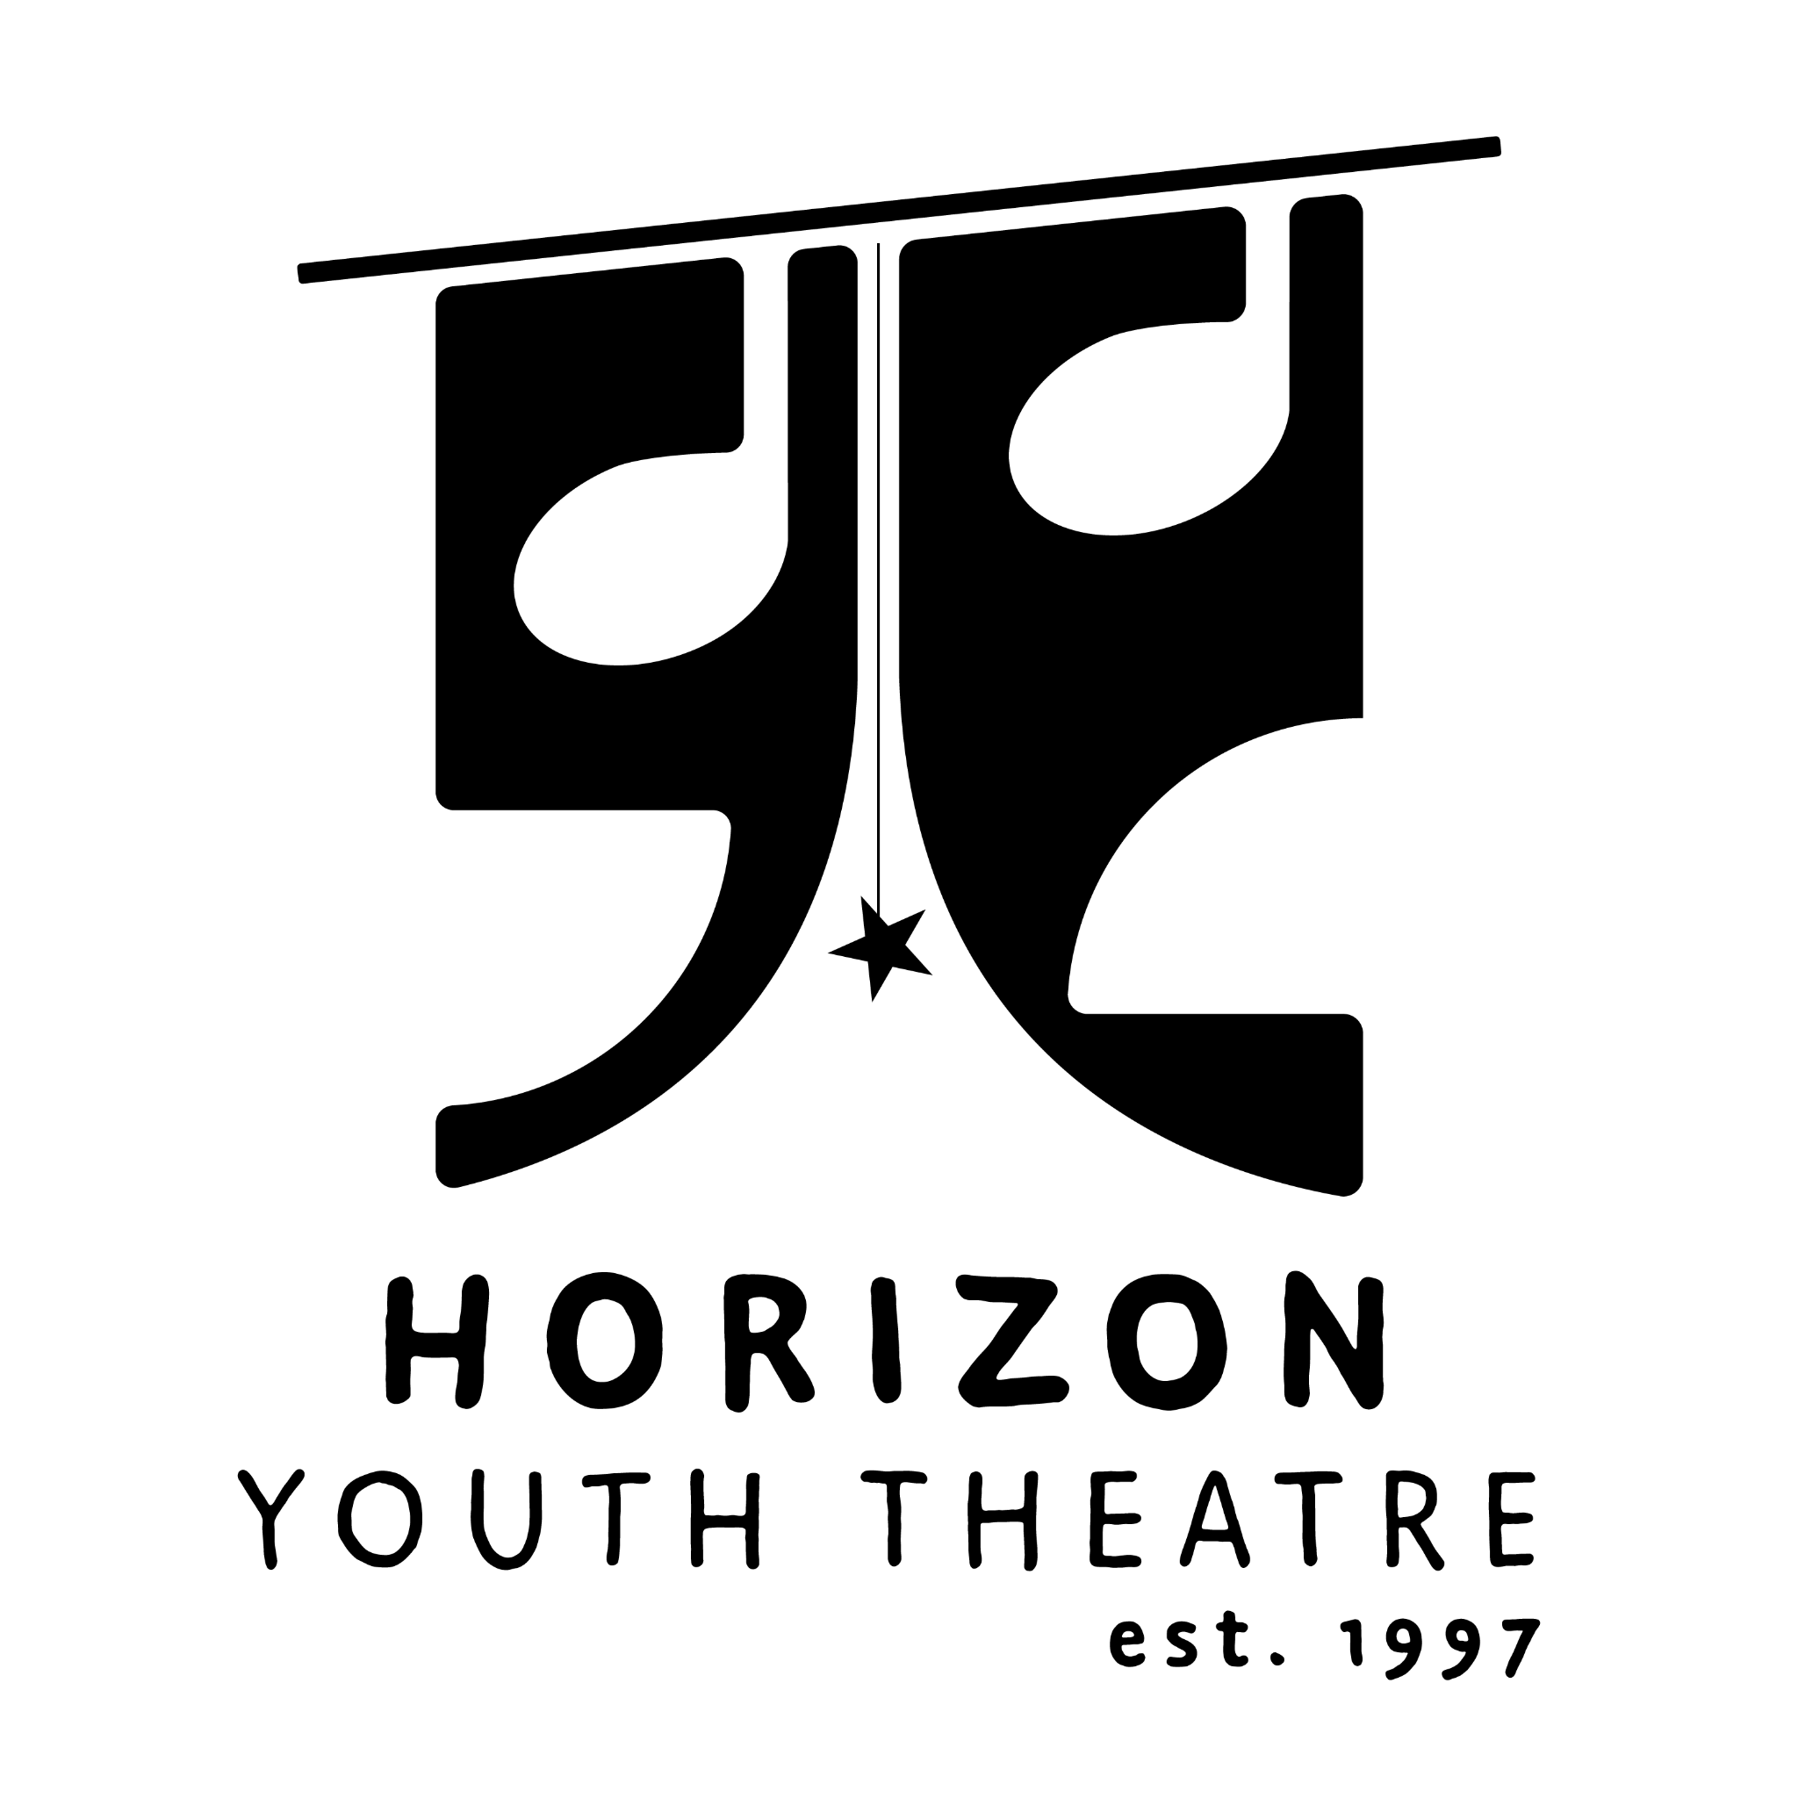
Horizon Youth Theatre Board Candidate Application
Please turn in to Liz Robertson at president@horizonyouththeatre.org
Name _______________________________________________________________________________
First MI Last
Address _____________________________________________________________________________
Cell Phone __________________________________ E-mail _________________________________
Employer
Employer Name ______________________________________________________________________
Your title ____________________________________________________________________________
Type of business or organization _______________________________________________________
Primary service(s) and area/population served ____________________________________________
Please list boards and committees that you serve on, or have served on (business, civic, community, fraternal, political, professional, recreational, religious, social).
Organization Role/Title Dates of Service
_____________________________________________________________________________________ __________________________________________________________________________________________________________________________________________________________________________
Education/Training/Certificates
_______________________________________________________________________________________________________________________________________________________________________________________________________________________________________________________________
Optional – Have you received any awards or honors that you’d like to mention?
_______________________________________________________________________________________________________________________________________________________________________________________________________________________________________________________________
What do you hope to contribute to Horizon Youth Theatre as a board member?
_______________________________________________________________________________________________________________________________________________________________________________________________________________________________________________________________
Skills, experience and interests (Please circle or highlight all that apply)
Finance, accounting
Personnel, human resources
Administration, management
Nonprofit experience
Community service
Policy development
Program evaluation
Public relations, communications
Education, instruction
Special events
Grant writing
Fundraising
Outreach, advocacy
Diversity, Equity, Inclusion
Other _______________________
Other _______________________
Please list any groups, organizations, or businesses that you could serve as a liaison to on behalf of Horizon Youth Theatre.
_____________________________________________________________________________________ __________________________________________________________________________________________________________________________________________________________________________
Please tell us anything else you’d like to share.
_____________________________________________________________________________________ __________________________________________________________________________________________________________________________________________________________________________
Thank you for applying, we will be in contact with you shortly

